한글 논문제목
(영문 논문제목: English Title)

(한글저자명) 제1저자^{1,2†}, 제2저자², 제3저자³, 제4저자⁴
(영문저자명) Journal Kim^{1,2†}, Space Science Lee², Space-Science Park³, Space S. Choi⁴

(저자소속) 소속은 국문/영문으로 모두 표기
¹한국항공우주연구원
²
³
⁴
¹Korea Astronomy and Space Science Institute, Daejeon 34055, Korea
²Southwest Research Institute, San Antonio, Texas 78238, USA
³University of Science and Technology, 217 Gajung-ro, Yuseong-gu, Daejeon, 34113, Korea
⁴Korea Astronomy and Space Science Institute, Daejeon 34055, Korea

† Corresponding Author
E-mail: jsta@ksss.or.kr
Tel: +82-42-865-3351

ORCIDs (“모든” 저자의 ORCID 입력)
Journal Kim: https://orcid.org/0000-0000-0000-0000
Space Science Lee: https://orcid.org/0000-0000-0000-0000
Space-Science Park: https://orcid.org/0000-0000-0000-0000
Space S. Choi: https://orcid.org/0000-0000-0000-0000

Received: (blank) Revised: (blank) Accepted: (blank)

Heading title: 제1저자 등 + (논문의 축약제목. 국문논문은 국문, 영문논문은 영문으로)

요 약

한글 요약문 작성 ………………………………………………………………………………………………………………………………………………………………………………………………………………………………………………………………………………………………………………………………………………………………………………………………………………

영문 Abstract (300단어 내외)

Place the English abstract here…
………………………………………………………………………………………………………………………………………………………………………………………………………………………………………………………………………………………………………………………………………………………………………………………………………………

한글키워드: 국문키워드도 영문과 동일하게 작성 부탁 드립니다.
Keywords: keyword1, keyword2, keyword3…

- 서론

서론은… 참고문헌 (1). 다음은 … 참고문헌 (2, 3). 또한 … 참고문헌 (4-6).
따라서 …
- 모델

일반적으로 … 식은 다음과 같다.
$${\left(cθ∆t\right)}^{2}\left[-∇^{2}{\text{E}}^{n+1}-∇∇∙\left(μ^{n}∙{\text{E}}^{n+1}\right)\right]+{(I+μ)}^{n}∙{\text{E}}^{n+1}$$$={\text{E}}^{n}+\left(cθ∆t\right)\left(∇×{\text{B}}^{n}-\frac{4π}{c}{\hat{J}}^{n}\right)-{\left(cθ∆t\right)}^{2}∇4π{\hat{ρ}}^{n},$ (1)

여기서….. $35 eV$ 에너지를 가지는 이온의 속도는 $81.9 km/s$로 주어지고 플라즈마 밀도는 $3 {cm}^{-3}$로 가정하였다. 쌍극자 모멘트는 $1.12×{10}^{12} {Am}^{2}$로 가정하였다. Table 1에 제시된 바와 같이…..

- 결과
Fig. 1은 다음의 …
Fig. 1 (a)에 나타난 …

- 결론
본 논문에서는…..

감사의 글
본 연구는 한국연구재단의 …..

References
(☞ 참고문헌은 영어로 작성. 아래는 참고문헌종류별 작성 스타일)
Journal articles:
1. Takahashi K, McPherron RL, Hughes WJ, Multispacecraft observations of the harmonic structure of Pc3-4 magnetic pulsations, J. Geophys. Res. 89, 6758-6774 (1984). https://doi.org/10.1029/JA089iA08p06758
2. Hwang KJ, Kuznetsova MM, Sahraoui F, Goldstein ML, Lee E, et al., Kelvin-Helmholtz waves under southward interplanetary magnetic field, J. Geophys. Res. 116, A08210 (2011). https://doi.org/10.1029/2011JA016596
Book, Book in series:
3. Kelley MC, The Earth’s Ionosphere (Academic Press, San Diego, 1989).

Articles from book, conference or symposium proceedings:
4. Holmberg E, Magnitudes, colors, surface brightness, intensity distributions, absolute luminosities, and diameters of galaxies, in stars and stellar systems, vol. 9, Galaxies and the Universe, eds. Sandage A, Sandage M, Kristian J (Univ. Chicago Press, Chicago, 1975), 123-157.
5. Capitaine N, Gambis D, McCarthy DD, Petit G, Pay J, et al., Proceedings of the IERS Workshop on the Implementation of the New IAU Resolutions, Observatoire de Paris, Paris, France, 18-19 Apr 2002.
6. Kim K, Hwang J, Sung S, Geosynchronous magnetic field variations associated with the passage of interplanetary shocks or solar wind discontinuities, in 2007 AGU Fall Meeting, San Francisco, CA, 10-14 Dec 2007.
Technical report:
7. Mazanek DD, Roithmayr CM, Antol J, Park SY, Koons RH, et al., Comet/asteroid protection system (CAPS): preliminary space-based system concept and study results, NASA Langley Research Center Technical Report, NASA/TM-2005-213758 (2005).
Dissertation:
8. Park SY, Optimization and guidance of ascent trajectories with inequality constraints, PhD Dissertation, Texas A&M University (1996).
Website:
9. National Radio Astronomy Observatory, Very long baseline array (2009) [Internet], viewed 2011 Feb 20, available from: https://www.vlba.nrao.edu
[참고문헌 작성예시]
- Bamford RA, Kellett B, Bradford WJ, Norberg C, Thornton A, Gibson KJ, Crawford IA, Silva L, Gargate L, Bingham R, Minimagnetospheres above the lunar surface and the formation of lunar swirls, Phys. Rev. Lett. 109, 081101(2012). https://doi.org/10.1103/PhysRevLett.109.081101
- Deca J, Divin A, Lapenta G, Lembege B, Markidis S, Horányi M, Electromagnetic particle-in-cell simulations of the solar wind interaction with lunar magnetic anomalies, Phys. Rev. Lett. 112, 151102(2014). https://doi.org/10.1103/PhysRevLett.112.151102
- Deca J, Divin A, Lembege B, Horanyi M, Markidis S, Lapenta G, General mechanism and dynamics of the solar wind interaction with lunar magnetic anomalies from 3-D particle-in-cell simulations, J. Geophys. Res. 120, 6443–6463(2015). https://doi.org/10.1002/2015JA021070.
[표/Table 예시]
(☞ 표의 내용과 제목은 영어로 작성)
Table 1. Available dataset and number of detected Pc1 waves between 2009–2018.
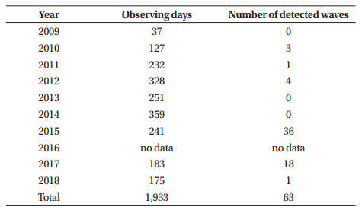

[Figure 예시]
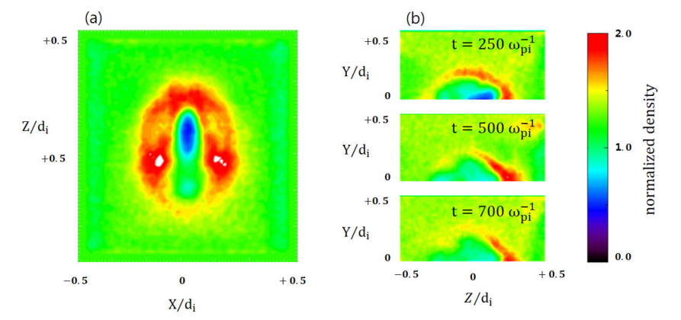
Fig. 1. 3D simulation results: (a) ion density on the lunar surface at $t=250 ω_{pi}^{-1}$ and (b) ion density on the central cross section of $x=0.5 d_{i}$ at $t=250 ω_{pi}^{-1}$, $500 ω_{pi}^{-1}$, and $700 ω_{pi}^{-1}$.
(☞ 그림과 캡션은 영어로 작성)

논문 맨 마지막 페이지에는 저자정보에 사용될 정보가 필요합니다. 사진+이메일+관심분야 (하단 예시참조)

